**Key Formulas and Relations in OS**

1. **Turnaround Time (TAT)**

The total time taken from the submission of a process to its completion.

Formula:

Turnaround Time = Completion Time - Arrival Time

**2. Waiting Time (WT)**

The total time a process spends in the ready queue, waiting to be executed.

Formula:

Waiting Time = Turnaround Time - Burst Time

**3. Response Time (RT)**

The time from the submission of a request until the first response is produced (not the completion).

Formula:

Response Time = First Response Time - Arrival Time

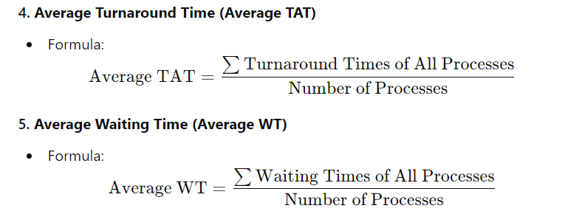

**6. Burst Time (BT)**

The total time a process needs to execute on the CPU.

It is generally provided as input in numerical problems.

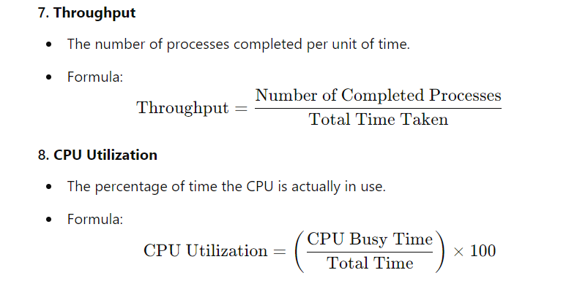

**Process Scheduling Techniques**

**Pre emptive Scheduling**

CPU is allocated to processes for a limited time. Can be interrupted.

Examples:

Round Robin (RR) Shortest Remaining Time First (SRTF)

**Non-pre emptive Scheduling**

Once a process starts its execution, it cannot be interrupted until it finishes.

Examples:

First Come First Serve (FCFS) Shortest Job First (SJF)

**Memory Management**

**Paging**

Divides the process into fixed-size pages and the memory into fixed-size frames.

Formula:

Effective Access Time = Memory Access Time + (Page Fault Rate) *(Page Fault Service Time)

**Segmentation**

Divides the memory into variable-sized segments based on the logical divisions of a process.

**Virtual Memory**

**Page Fault**

Occurs when the requested page is not in memory.

Page Fault Rate (PFR) is the percentage of page references that result in a page fault.

**Thrashing**

A situation where excessive paging leads to reduced performance due to the system spending more time swapping pages than executing the process.

**Page Replacement Algorithms**

- **FIFO** (First-In-First-Out): Replace the oldest page.

- **LRU** (Least Recently Used): Replace the least recently used page.

- **Optimal:** Replace the page that will not be used for the longest time.

**Concurrency and Synchronization**

**Deadlock**

A situation where processes are waiting indefinitely for resources that are held by each other.

Deadlock Prevention, Avoidance, Detection, and Recovery methods are used to handle deadlocks.

**Semaphores and Mutexes**

Used to ensure mutual exclusion and handle critical section problems.

**Semaphore:** Integer variable used to control access to a resource.

**Mutex:** A lock that allows only one process to access a resource at a time.

**Possible Numerical Questions**

**1. Turnaround Time, Waiting Time, and Response Time Calculation:**

Given arrival time, burst time, and scheduling order, calculate TAT, WT, and RT for processes.

**2. CPU Scheduling:**

Calculate Average Turnaround Time and Average Waiting Time for different scheduling algorithms like FCFS, SJF, Round Robin, etc.

**3. Page Replacement Algorithms:**

Given a reference string and frame size, calculate the number of page faults using FIFO, LRU, or Optimal algorithms.

**4. Memory Access Time:**

Given memory access time, page fault rate, and page fault service time, calculate effective access time in a paging system.

